COURSE CODE/TITLE: | CPE 010 |  | SECTION: | CPE21S3
DATE PERFORMED: | 9/29/26 |  | DATE SUBMITTED: | 9/29/26
NAME: | Ralf Nicolo B. Abello |  | INSTRUCTOR: | Engr. Jimlord Quejado

ACTIVITY NO. 10.1 | Graph
1. PROCEDURE OUTPUT
Definitions
A. Graph: A non-linear data structure made up of nodes (vertices) and edges. The edges connect any two nodes in the graph.
B. Vertex: A single point in a graph that edges connect. Vertices are also called nodes (for example, A in the figure).
C. Nodes: Another name for vertices. The two terms are used interchangeably.
D. Weight: A value attached to an edge, written w(u, v). Each edge has a weight given by the weight function W: E → R.
E. Path: A path of length k from u to u' is a sequence of vertices (v₀, v₁, …, vₖ) with u = v₀, u' = vₖ, and (vᵢ₋₁, vᵢ) ∈ E. It is simple if all its vertices are distinct. If a path exists from u to u', then u' is reachable from u.
F. Directed graph: A graph (also called a digraph) in which each edge has a direction, shown as an arrow from one vertex to another.
G. Connected graph: In an undirected graph, a connected component is a subset of vertices that are all reachable from each other. The graph is connected if it has exactly one connected component, meaning every vertex is reachable from every other. In a directed graph, a strongly connected component is a subset of mutually reachable vertices, meaning there is a path between any two vertices in the set.
H. Directed cyclic: A directed graph that contains a cycle. A cycle is a path with v₀ = vₖ, so following the arrows leads back to the starting vertex. A graph with no cycles is acyclic, and a directed acyclic graph is known as a DAG.
I. Adjacency matrix: A 2D array of size V × V, where V is the number of nodes. For an unweighted graph, matrix[i][j] = 1 if there is an edge from node i to node j, and 0 otherwise. For a weighted graph, w(u, v) is stored at location (u, v). It needs V² memory and is preferred for dense graphs or when I need to quickly check whether an edge exists.
J. Adjacency list: An array of lists whose size equals the number of nodes. The entry array[i] holds the list of nodes adjacent to the ith node. For a weighted graph, w(u, v) is stored along with vertex v in u's list. It needs |V| + |E| memory, is preferred for sparse graphs, and works for both directed and undirected graphs.

Parts of the Graph

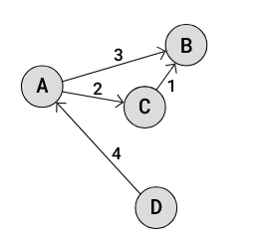
- Type: Weighted, directed graph (digraph)
- Vertices (nodes): A, B, C, D, so |V| = 4
- Edges: |E| = 4, each with a direction and a weight:
  - (A, B) with weight w = 3
  - (A, C) with weight w = 2
  - (C, B) with weight w = 1
  - (D, A) with weight w = 4
- Example path: (D, A, C, B) has length k = 3 and total weight 4 + 2 + 1 = 7. It is a simple path because all its vertices are distinct. Since this path exists, B is reachable from D.
- Cycles: None, so the graph is acyclic. Because it is also directed, it is a DAG.
- Connectivity: The graph is not strongly connected. For example, there is no path from B to any other vertex, so no two vertices are mutually reachable. Each vertex is its own strongly connected component.

Adjacency Matrix
The vertex order is A, B, C, D. Rows are the starting vertex and columns are the ending vertex. Since the graph is weighted, w(u, v) is stored at location (u, v), and 0 means there is no edge.
 | A | B | C | D
A | 0 | 3 | 2 | 0
B | 0 | 0 | 0 | 0
C | 0 | 1 | 0 | 0
D | 4 | 0 | 0 | 0

C++ Program
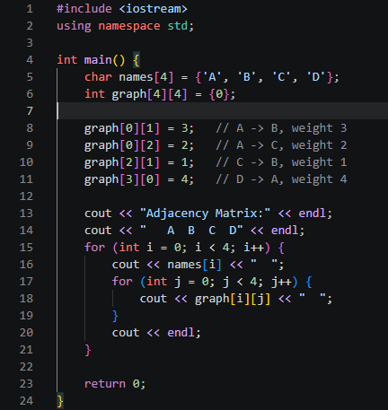
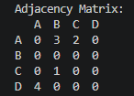

BFS vs DFS
Feature | Breadth-First Search (BFS) | Depth-First Search (DFS)
Idea | Starts at a source node and traverses the graph layerwise, exploring the neighbors directly connected to the source, then moving to the next-level neighbors | Uses the idea of backtracking, it exhaustively searches by going ahead if possible, otherwise backtracking along the same path
Order of visiting | Visits all nodes of the current layer horizontally, then moves to the next layer | Visits all nodes on the current path until no unvisited nodes remain, then selects the next path
Order of visiting | Queue (add to the back, take from the front) | Stack (add to the top, take from the top), it can also be written recursively
Steps | 1. Put a starting vertex at the back of the queue. 2. Take the front item and add it to the visited list. 3. Add its unvisited adjacent nodes to the back of the queue. 4. Repeat steps 2 and 3 until the queue is empty. | 1. Put a starting vertex on top of the stack. 2. Take the top item and add it to the visited list. 3. Add its unvisited adjacent nodes to the top of the stack. 4. Repeat steps 2 and 3 until the stack is empty.

2. ANSWERS TO SUPPLEMENTAL ACTIVITY
Copy and paste the questions from the lab and include your answers after.

3. ARTIFICIAL INTELLIGENCE (AI) USE DISCLOSURE STATEMENT
I hereby declare that artificial intelligence (AI) tools were used, if applicable, in the preparation of this academic work. The following indicates the nature and extent of AI assistance:

Tools Used: | ChatGPT
Examples: ChatGPT, Microsoft Copilot, Grammarly, QuillBot, etc.

Purpose of Use: | Code assistance
Examples: grammar correction, idea generation, formatting, summarization, code assistance, explanation of concepts, etc.

Extent of Use:
Explain how AI was used and confirm that it did not replace original thinking, analysis, authorship, or completion of the required work.

By submitting this activity, I affirm that my use of AI complies with T.I.P.’s AI usage policy and does not exceed the permitted limits for similarity, automated content generation, or academic assistance.

I understand that any false, incomplete, or misleading disclosure may be subject to investigation in accordance with due process and may result in sanctions for violation of existing T.I.P. policies.

Lab activities, templates, and related instructional materials shall not be reuploaded, reproduced, distributed, or shared with external organizations or third parties without the prior express written permission of the Technological Institute of the Philippines.

